|  |  |
| --- | --- |
| **Number Code** | **Description** |
| General | General number format. |
| 0 (zero) | Digit placeholder. This code pads the value with zeros to fill the format. |
| # | Digit placeholder. This code does not display extra zeros. |
| ? | Digit placeholder. This code leaves a space for insignificant zeros but does not display them. |
| . (period) | Decimal number. |
| % | Percentage. Microsoft Excel multiplies by 100 and adds the % character. |
| , (comma) | Thousands separator. A comma followed by a placeholder scales the number by a thousand. |
| E+ E- e+ e- | Scientific notation. |

|  |  |
| --- | --- |
| **Text Code** | **Description** |
| $ - + / ( ) : space | These characters are displayed in the number. To display any other character, enclose the character in quotation marks or precede it with a backslash. |
| *character* | This code displays the character you specify.  Note Typing !, ^, &, ', ~, {, }, =, <, or > automatically places a backslash in front of the character. |
| "text" | This code displays text. |
| * | This code repeats the next character in the format to fill the column width.  Note Only one asterisk per section of a format is allowed. |
| _ (underscore) | This code skips the width of the next character. This code is commonly used as "_)" (without the quotation marks) to leave space for a closing parenthesis in a positive number format when the negative number format includes parentheses. This allows the values to line up at the decimal point. |
| @ | Text placeholder. |

|  |  |
| --- | --- |
| **Date Code** | **Description** |
| m | Month as a number without leading zeros (1-12) |
| mm | Month as a number with leading zeros (01-12) |
| mmm | Month as an abbreviation (Jan - Dec) |
| mmmm | Unabbreviated Month (January - December) |
| d | Day without leading zeros (1-31) |
| dd | Day with leading zeros (01-31) |
| ddd | Week day as an abbreviation (Sun - Sat) |
| dddd | Unabbreviated week day (Sunday - Saturday) |
| yy | Year as a two-digit number (for example, 96) |
| yyyy | Year as a four-digit number (for example, 1996) |

|  |  |
| --- | --- |
| **Time Code** | **Description** |
| h | Hours as a number without leading zeros (0-23) |
| hh | Hours as a number with leading zeros (00-23) |
| m | Minutes as a number without leading zeros (0-59) |
| mm | Minutes as a number with leading zeros (00-59) |
| s | Seconds as a number without leading zeros (0-59) |
| ss | Seconds as a number with leading zeros (00-59) |
| AM/PM am/pm | Time based on the twelve-hour clock |

|  |  |
| --- | --- |
| **Miscellaneous Code** | **Description** |
| [BLACK], [BLUE], [CYAN], [GREEN], [MAGENTA], [RED], [WHITE], [YELLOW], [COLOR *n*] | These codes display the characters in the specified colors.   Note *n* is a value from 1 to 56 and refers to the nth color in the color palette. |
| [*Condition* *value*] | *Condition* may be <, >, =, >=, <=, <> and v*alue* may be any number.  Note A number format may contain up to two conditions. |

Clear presentation of numerical and logical information in Excel is fundamental when you want to improve usability of your financial models. Custom number formats in Excel is critical to good presentation.

This Tutorial outlines different key techniques which can be quickly applied to any project finance model, and is recommended for Excel users at all levels.

Excel often formats numbers as it sees fit, for example, if the user types in 10%, Excel will automatically format this cell as a percentage and any future values entered into this cell will be formatted similarly. To custom format a cell click on the target cell then go to Format -> Cells (the shortcut is Ctrl+1). The Format Cells window should look like this:

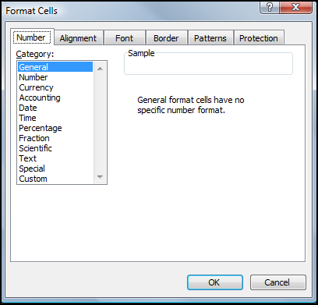

**How to Set Custom Number Formats in Excel**

To set custom formats click on “Custom” in the Category.

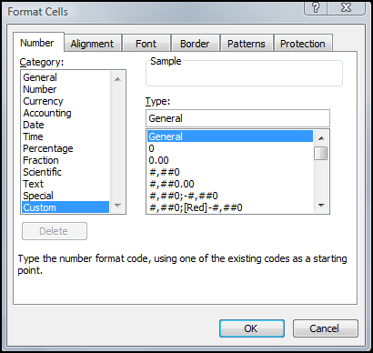

The custom format is entered under Type. Excel allows for four (4) format sections:

0.00 ; (0.00) ; 0.00 ; “Text “@   
(Positive) (Negative) (Zero) (Text)

Each section needs to be separated by a semi colon “;”. 0 represents where the numbers should appear, for example to display 2 d.p. “0.00” is used and for no d.p. “0” will suffice.

To use commas as separators “0,000” is required. Only the Positive section is mandatory by Excel. By omitting all of the other sections Excel will assume the positive format. If however the user wishes to customize the zero section, all sections prior, i.e. Positive and Negative sections must be specified or empty cells will be displayed for the value corresponding to the omitted section.

**Examples of custom formats in Excel**

**Comma with 2 Decimal Places**

Type is written as: 0,000.00; (0,000.00);

The format represents 2 d.p. for positive values with comma separators (“0,000.00”), 2 d.p. enclosed in brackets for negative numbers with comma separators (“(0.00)”) and zero displayed as a dash (“-”)

**Comma with No Decimal Places**

Type is written as: 0,000; (0,000); -

Here the format is quite similar to 2 d.p. but with “.00” removed to represent zero d.p.

**Combining Text and Numbers in a custom format**

Type is written as: For Op Qtr 1 – “Op Qtr” 0, and for 5.25 yrs – “0.00” yrs

To combine text and number the text portion must be enclosed by double apostrophes. Negative, Zero and Text sections are omitted.

**Ratios**

Type is written as: 0.00“x”

This is another example of combining text and number however in this case there is no space between 0.00 and “x” as x should follow immediately after the number.

**Percentages with 0% Displayed as “-”**

Type is written as: 0%; -0%; -

Since the zero section is customised, both Positive and Negative sections must be specified as well.

**Displaying 1 and 0 as “Yes” and “No”**

Type is written as: “Yes”; ; “No”

Because 1 is a positive number only the Positive and Zero sections need be defined. Any positive number will return “Yes” but if a negative value is entered the cell will remain empty as the Negative section is undefined.

To demonstrate the custom number formats in the above examples, we have put in a sample workbook. To view the number formats in certain cell, click on the cell then go to Format -> Cells -> Number -> Custom.

The format cells in the above examples are as illustrated in the screenshot below.

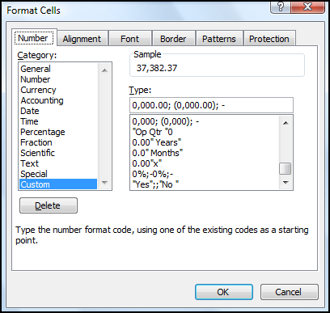

Advanced Custom Number Formatting

If you want to explore more advanced features of the custom formatting in Excel, look into the following features

#### ****Change negative number to zero with custom Format Cell****

Actually, we can for format a selection and show all negative numbers as zero. You can do it with following steps:

Step 1: Select the range that you will work with, in this case it's A1:E12.

Step 2: Right click the selection, and select the **Format Cell** item from the context menu.

Step 3: In the Format Cells dialog box,

* Click **Number** tab;
* Select the **Custom** in the category box;
* In the **type:** box, enter the **#,##0;"0"** , see the following screen shot

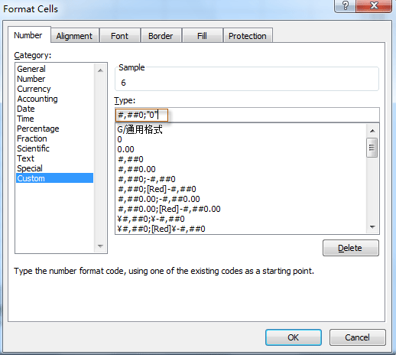

|  |  |
| --- | --- |
|  | The pound currency symbol |
| # | A digit if entered, left blank if no digit entered |
| , | Commas between thousands and millions |
| 0 | A zero if no digit entered (useful for leading and trailing zeros) |
| _ | (underscore) A space the width of the next character |
| [Red] | Font colour for the section (Must be placed at the beginning of the section) |
| () | Negative values in brackets |
| " " | Custom text, for example, "lbs" or "zero" |
| @ | Text as entered (only applies to the last formatting section) |